**FORMAN CHRISTIAN COLLEGE**

**(A CHARTERED UNIVERSITY)**



**Embedded Systems (CSCS 306)**

**FALL-2019**

**LAB-01**

**LEDs Basics**

**Group Members:**

* Mohammad Usman 20-10558
* Haris Naseer 20-10612
* Abeer Butt 20-10596

**Introduction:**

After the revision of the basic concepts of programming arduino for LEDs, this lab was supposed to evaluate us by writing a program in Arduino in such a way that make LEDs (connected to Arduino) glow to required sequence.

This lab consists of two parts LabTask1 and LabTask2.

**LabTask1:** Task1 was to glow 4 LEDs connected in a sequence in such a way that our program should make the LEDs glow in a chasing sequence, then blink 3-times and then glow out in reversed chasing sequence and this process should run infinitely.

**LabTask2:** Task2 was to prompt user for his/her name and then it should make the LEDs glow as many times as there are characters (except the spaces) present in the prompted name/string.

**Working Code:**

**LabTask1:**

int pin[] = {7, 8, 9, 10};

int noOfPins = 4;

int noOfBlinks = 3;

void setup()

{

// put your setup code here, to run once:

for (int i = 0; i < noOfPins ; i++)

{

pinMode(pin[i], OUTPUT);

}

Serial.begin(9600);

}

// blinking function

void blink()

{

for (int i = 0; i < noOfBlinks; i++)

{

// turn off leds

for (int j = 0; j < noOfPins; j++)

{

digitalWrite(pin[j], LOW);

}

delay(500);

// turn on leds

for (int j = 0; j < noOfPins; j++)

{

digitalWrite(pin[j], HIGH);

}

delay(500);

}

}

void loop()

{

// put your main code here, to run repeatedly:

// chasing sequence

for (int i = 0; i < noOfPins; i++)

{

digitalWrite(pin[i], HIGH);

delay(500);

}

// blinking function

blink();

// reverse chasing sequence

for (int i = (noOfPins - 1); i >= 0 ; i--)

{

digitalWrite(pin[i], LOW);

delay(500);

}

delay(500);

}

**LabTask2:**

int pin[] = {7, 8, 9, 10};

int noOfPins = 4;

int len;

String s;

void setup()

{

// put your setup code here, to run once:

for (int i = 0; i < noOfPins; i++)

{

pinMode(pin[i], OUTPUT);

}

Serial.begin(9600);

Serial.print("Enter Your Name: ");

while (Serial.available() == 0);

s = Serial.readString(); // read string

Serial.println(s); // print the string read

len = charCount(s); // count characters

Serial.print("Leds blinking ");

Serial.print(len);

Serial.println(" times.");

blink(len); // call blink function

}

// blinking function

void blink(int len)

{

for (int i = 0; i < len; i++)

{

// turn on leds

for (int j = 0; j < noOfPins; j++)

{

digitalWrite(pin[j], HIGH);

}

delay(500);

// turn off leds

for (int j = 0; j < noOfPins; j++)

{

digitalWrite(pin[j], LOW);

}

delay(500);

}

}

// character count function

int charCount(String s)

{

int count = 0;

char c;

// iterating over string

for (int i = 0; i < s.length() - 1; i++)

{

c = s.charAt(i); // get character

if (c != ' ' )

{

count++;

}

}

return count;

}

void loop()

{

// put your main code here, to run repeatedly:

}

**Circuit Diagram:**

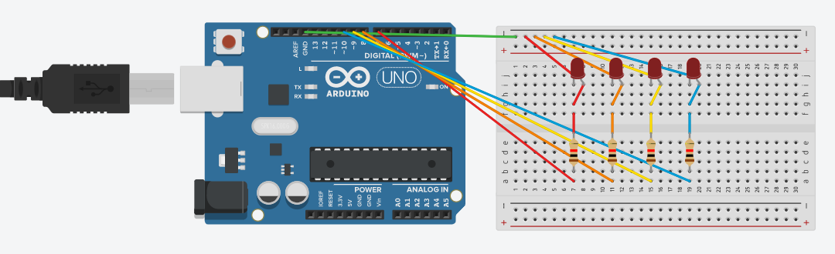

**Running Project Image:**

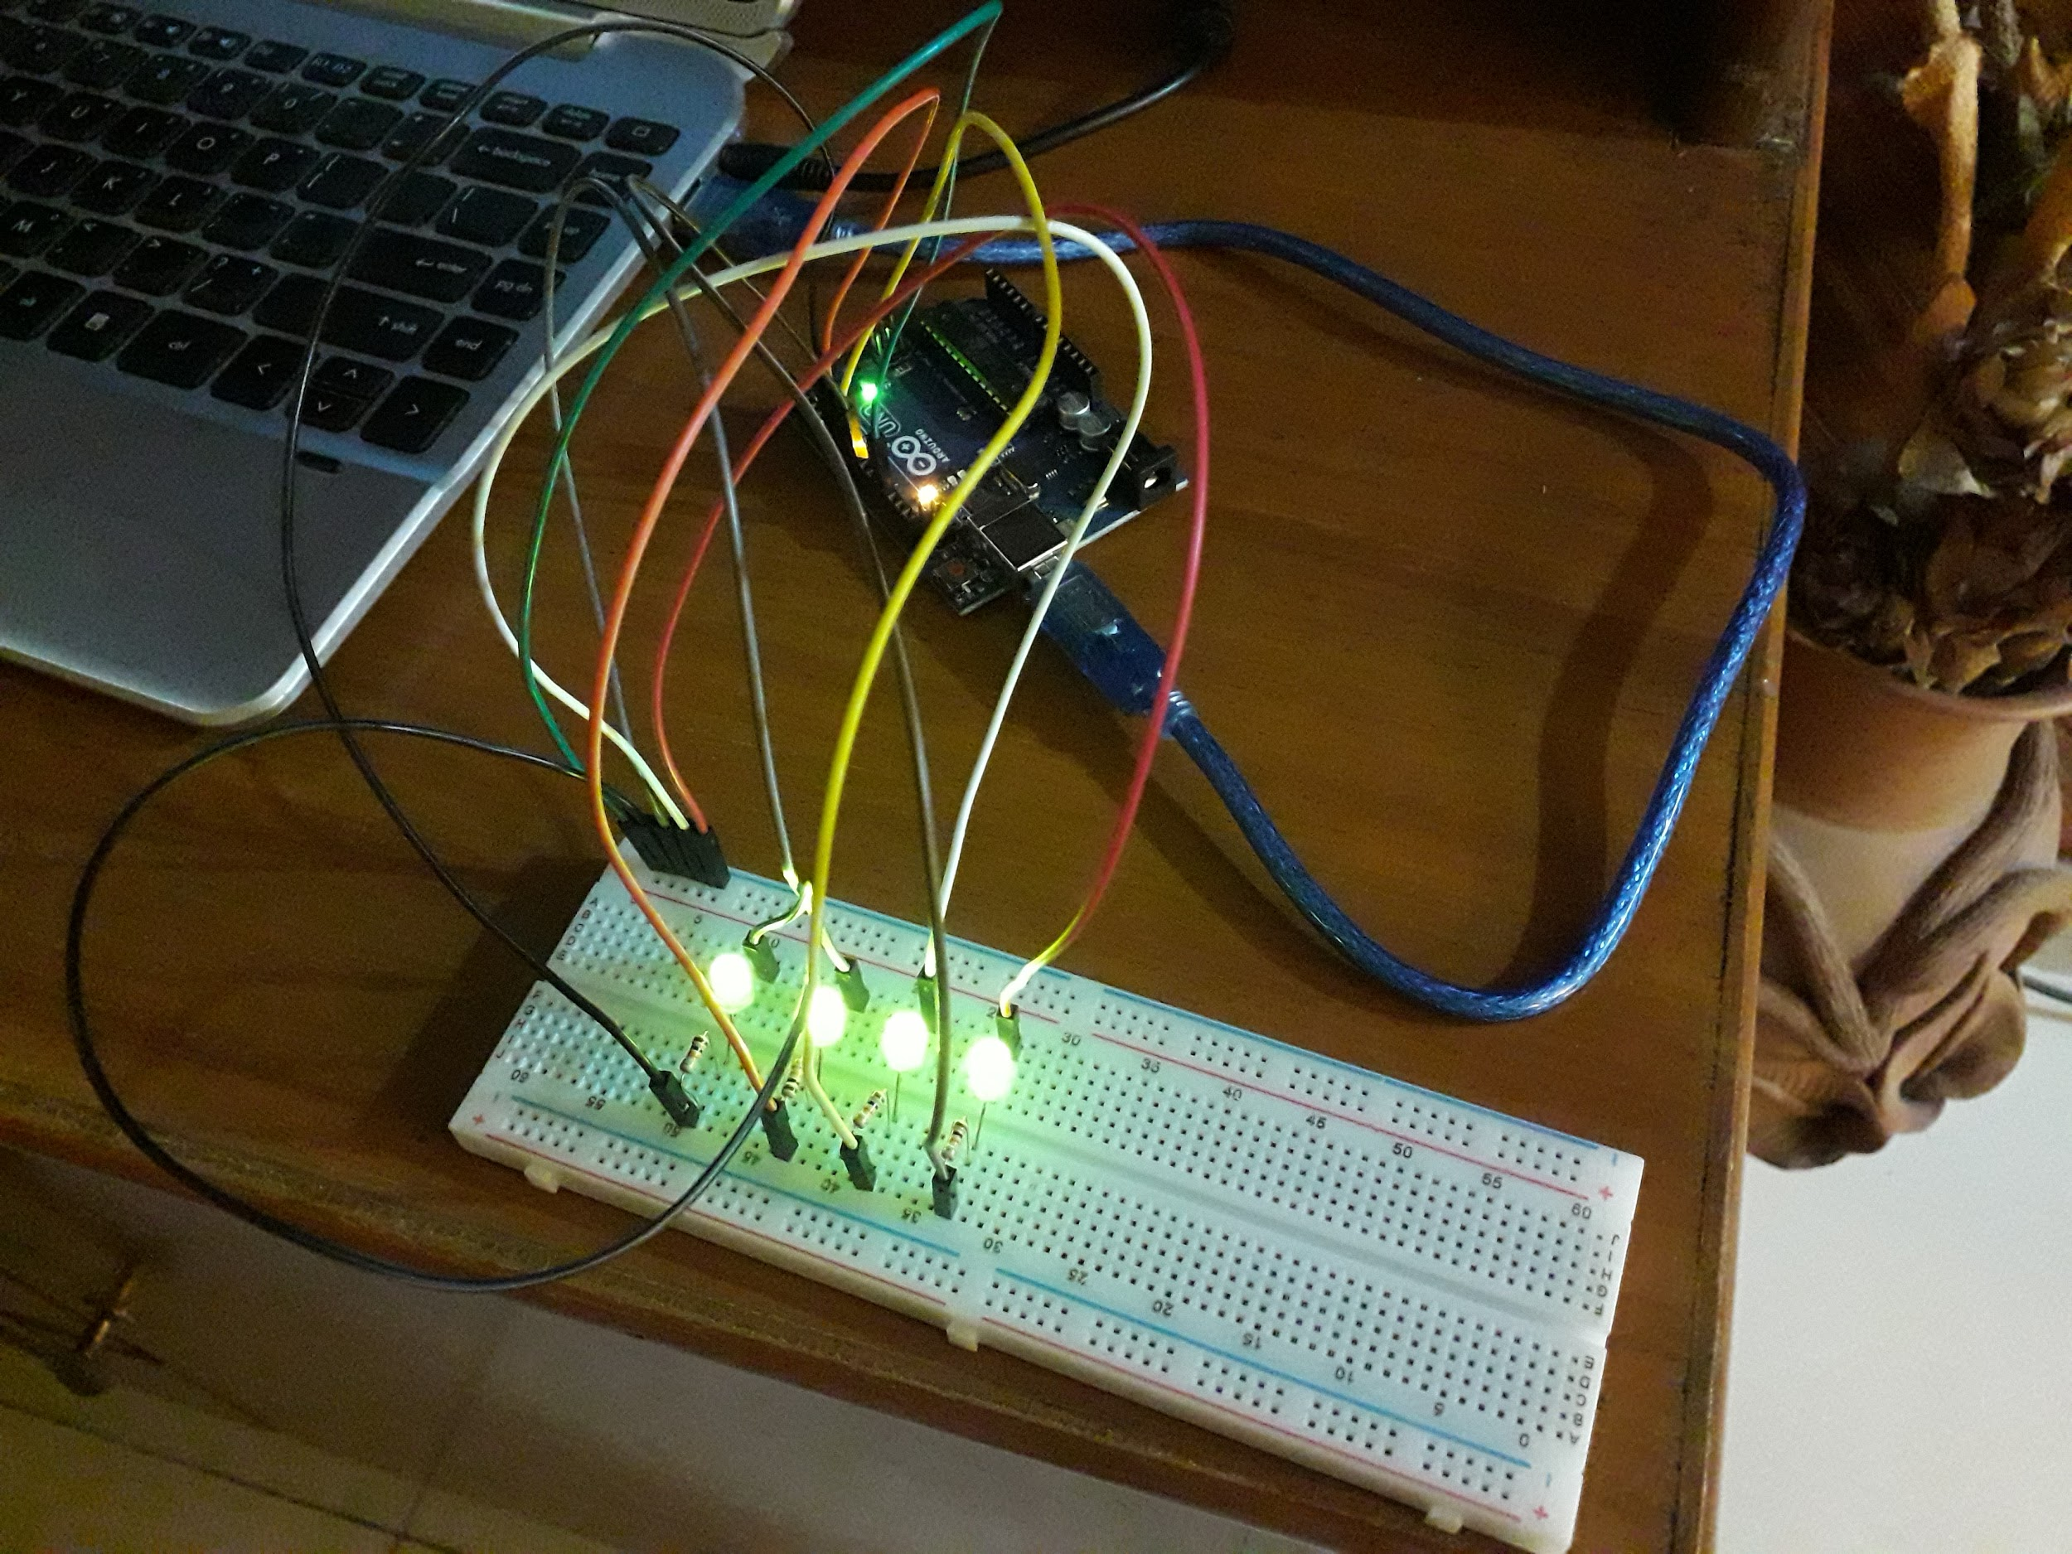

**Running Program Screenshots:**

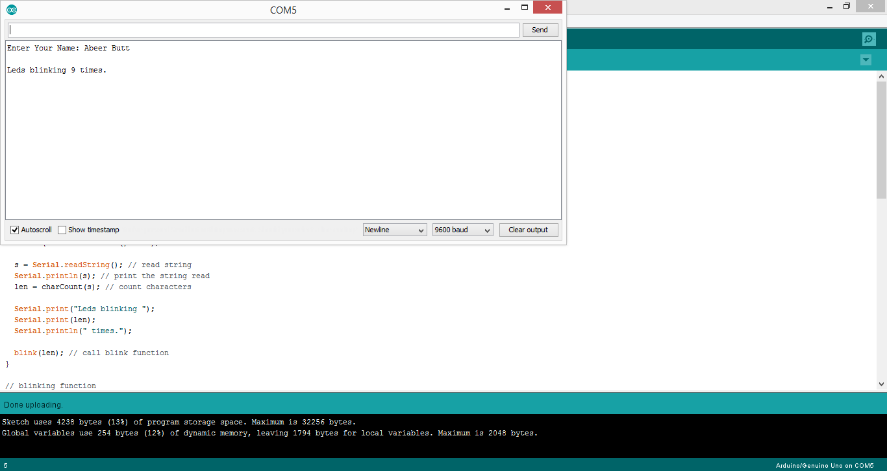

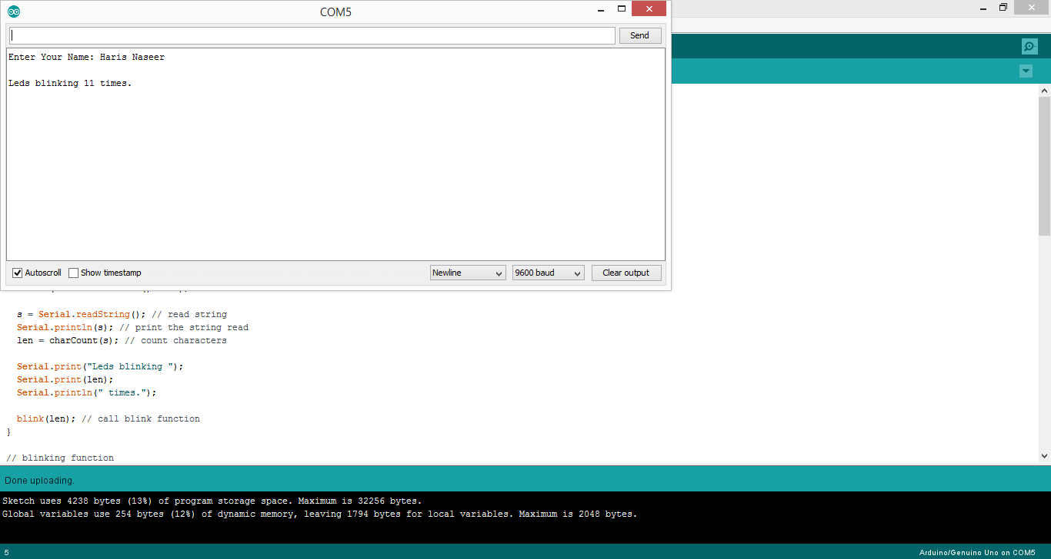

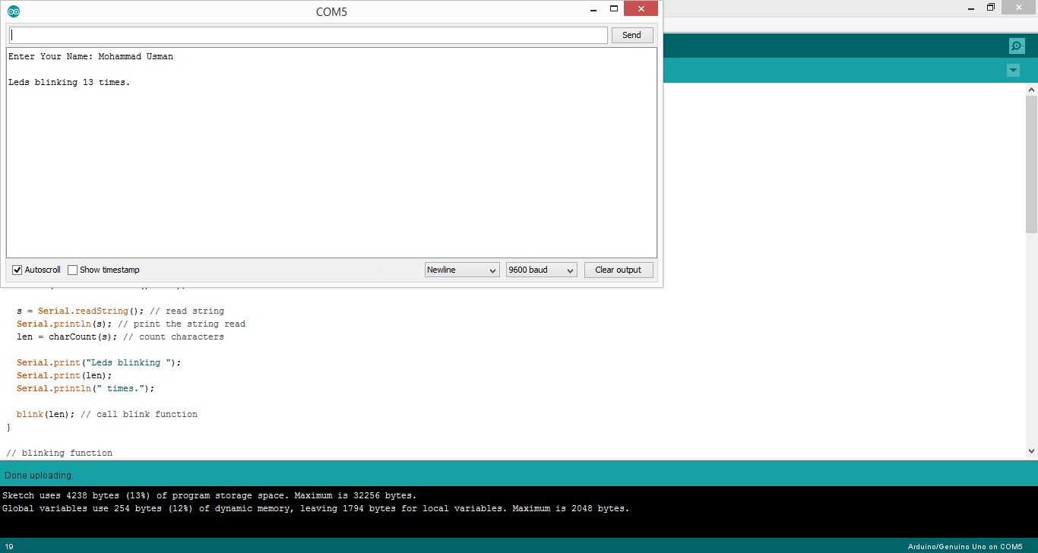

**References:**

* <https://www.arduino.cc/reference/en/language/variables/data-types/stringobject/>
* <https://www.arduino.cc/en/Tutorial/StringLength>
* <https://www.arduino.cc/reference/en/language/functions/communication/serial/available/>
* <https://www.arduino.cc/reference/en/language/variables/data-types/string/functions/charat/>